

**Discipline**

**ER diagram**

***(3 versions)***

**CS5201**

Stage-2

**Sheikh Muhammed Tadeeb (AU19B1014)**

* **Steps of forming Entity-Relation:**

**Step1) Identifying Entities:**

|  |  |  |
| --- | --- | --- |
| 1. USER | 1. BUSINESS | 1. GOODS |
| 1. PURCHASED | 1. SOLD | 1. VENDOR |
| 1. CUSTOMER | 1. CREDIT |  |

**Step2) Identifying Attributes and primary keys.**

1. USER (User_id, Username, Password)
2. BUSINESS (Business_name, B_type, B_location, B_PhoneNos, B_emailAdd)
3. GOODS (Goods_id, Goods_type)
4. PURCHASED (P_qty, P_date, P_time, P_cost)
5. SOLD (S_qty, S_date, S_time, S_cost)
6. VENDOR (Vendor_id, V_PhoneNos, V_emailAdd, V_location, F_name, M_name, L_name)
7. CUSTOMER (C_id, C_PhoneNos, C_emailAdd, C_location, F_name, M_name, L_name)
8. CREDIT (Amount_payed)

**Step3) Identifying relationship and cardinality among entities.**

|  |  |  |  |
| --- | --- | --- | --- |
| **Entities Involved** | **Relationship name** | **Attributes** | **Cardinality** |
| USER & BUSINESS | runs | User_id, Business_name | Many to Many  (M-M) |
| BUSINESS & GOODS | owns | Goods_id, Business_name | Many to Many  (M-M) |
| PURCHASED & VENDOR | Purchased from | Goods_id, Vendor_id | Many to Many  (M-M) |
| SOLD & CUSTOMER | Sold to | Goods_id, C_id | Many to Many  (M-M) |
| BUSINESS & CREDIT | Credit on | Business_name | One to One  (1-1) |
| CUSTOMER & CREDIT | Credit on | C_id | One to One  (1-1) |
| GOODS & CREDIT | Credit on | Goods_id | One to One  (1-1) |

**Step4) Participation Constraints:**

1. Goods can’t be sold unless and until its in the purchased goods record.
2. Although a business could be owned by many people but only one user will have access to application at a time.

**Step 5) Sign conventions used in ER-Model.**

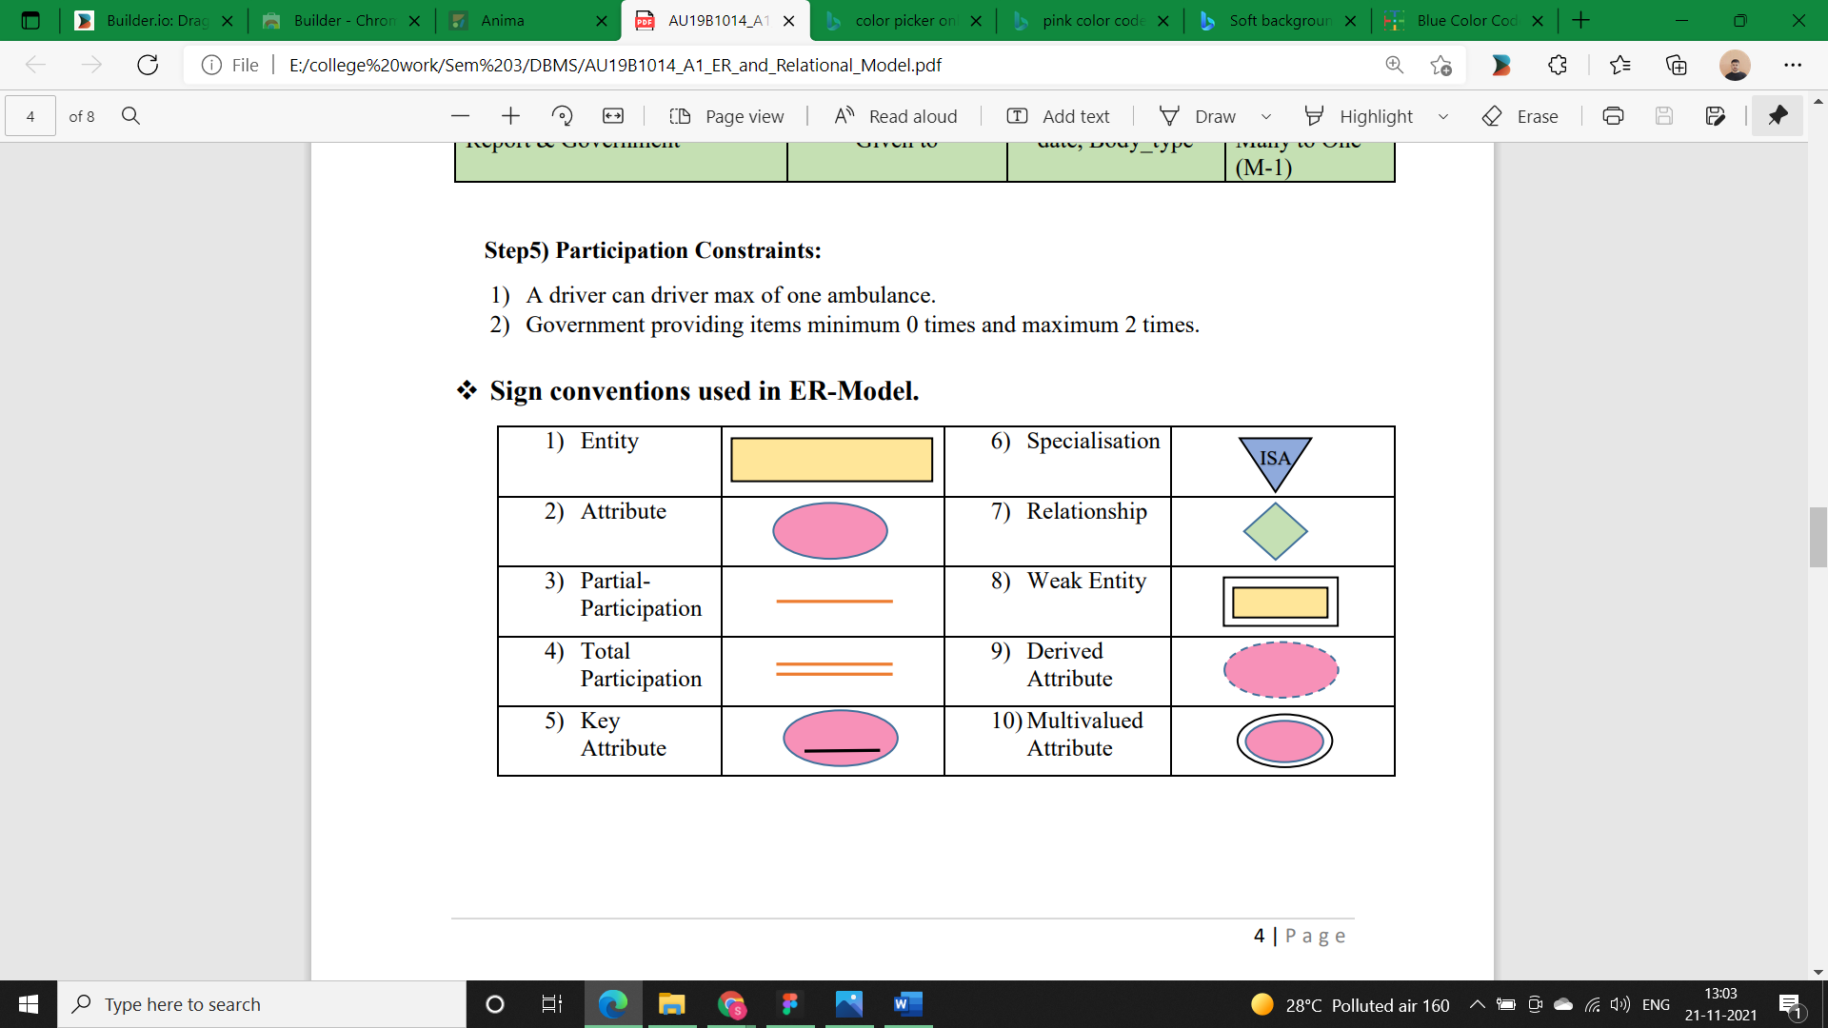

* **ER Model Version 1:**

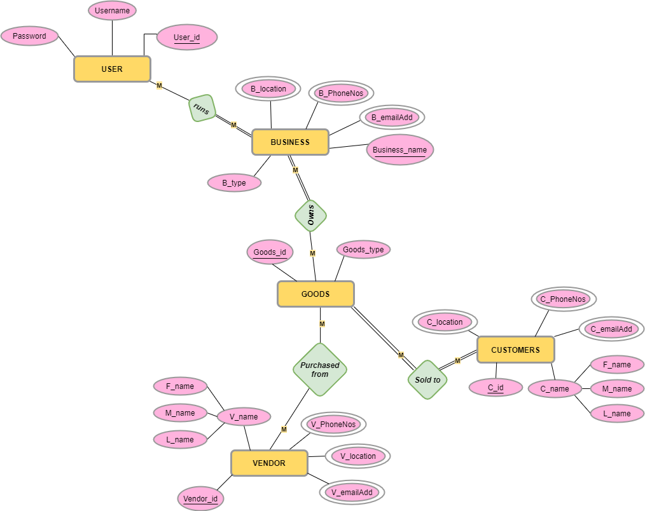

* **ER Model Version 2:**

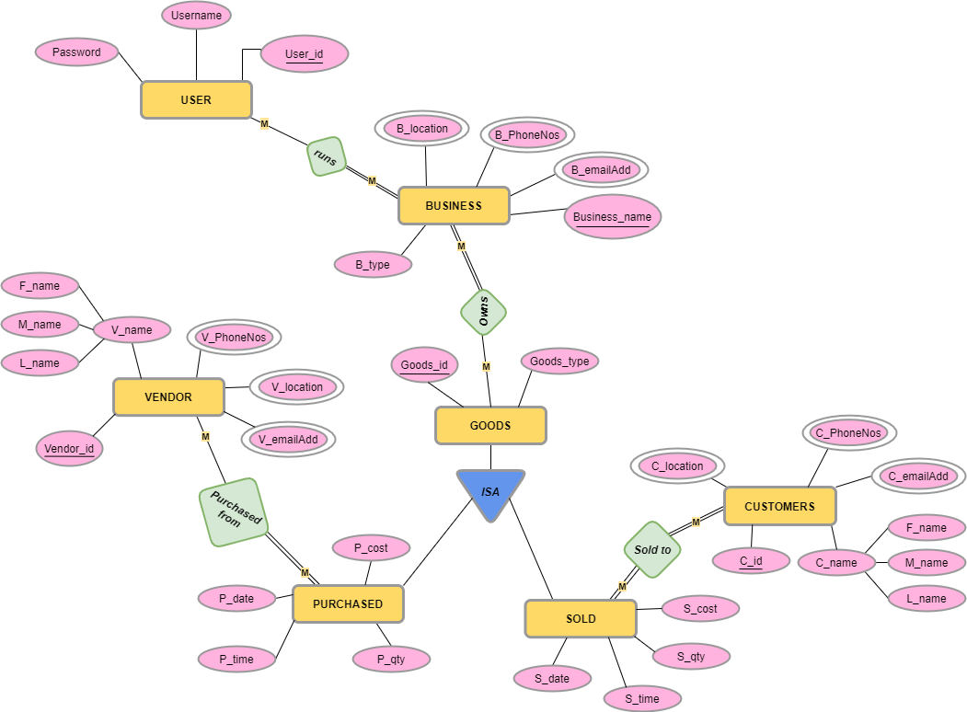

* **ER Model Version 3:**

